COURSE PROJECT REPORT
ENEE 624 FALL 2001

A Study of a various Beamforming Techniques
And
Implementation of the Constrained Least Mean Squares (LMS) algorithm for Beamforming

Vikas.C.Raykar
Graduate Student
Department of Electrical and Computer Engineering
University of Maryland, College Park
vikas@umiacs.umd.edu

Table of Contents
0.Abstract 2

1.Introduction to Beam forming 3

2.Beamformer Classification 4

3.Simple Delay and Sum Beamformer 5

4.Constrained LMS algorithm (Frost Beamformer) 7

5.Adaptive Algorithm for Frost Beamformer. 12

6.Simulation setup 14

7.Simulation results 20

8.Conclusion 27

References 28

APPENDIX : MATLAB Scripts

.

Chapter 0
ABSTRACT
A Beamformer is an array of sensors which can do spatial filtering. The objective is to estimate the signal arriving from the desired direction in the presence of noise and other interfering signals. A beamformer does spatial filtering in the sense that it separates two signals with overlapping frequency content originating from different directions. The aim of the project was to study the different beamforming techniques and use the Constrained Least Mean Squares (LMS) filter for spatial filtering. An array of microphones was simulated in MATLAB and a simple delay and sum beamformer was implemented. The results were compared with that of a single microphone and it was observed that beamforming definitely gives a significant SNR improvement. A Constrained least mean square algorithm (also known as Frost Beamformer) was derived which is capable of iteratively adapting the weights of the sensor array to minimize noise power at the array output while maintaining a chosen frequency response in the look direction. The adaptive version of the Frost beamformer was simulated in MATLAB and it was observed that there was a significant improvement in the SNR as compared to the simple delay and sum beamformer.

Chapter 1
INTRODUCTION TO BEAMFORMING

Spatially propagating signals encounter the presence of interfering signals and noise signals. If the desired signal and the interferers occupy the same temporal frequency band, then temporal filtering cannot be used to separate the signal from the interferers. However the desired and the interfering signals generally originate from different spatial locations. This spatial separation can be exploited to separate the signals from the interference using a beamformer. A beamformer consists of an array of sensors in a particular configuration. The output of each sensor is properly filtered and the filtered outputs of all the sensors are added up. Typically a beamformer linearly combines the spatially sampled waveform from each sensor in the same way a FIR filter linearly combines temporally sampled data. When low frequency signals are used an array of sensors can synthesize a much larger spatial aperture than that practical with a single physical antenna. A second very significant advantage of using an array of sensors is the spatial filtering versatility offered by discrete sampling. In many applications it is necessary to change the spatial filtering function in real time to maintain effective suppression of interfering signals. Changing the spatial filtering function of a continuous aperture antenna is impractical. Typical uses of beamforming arise in RADAR, SONAR, communications, imaging, Geophysical exploration, Biomedical and also in acoustic source localization.
Chapter 2
beamformer classification

Beamformers are classified as either data independent or statistically optimum, depending on how the weights are chosen. The weights in a data independent beamformer do not depend on the array data and are chosen to present a specified response for all signal and interference scenarios. The weights in a statistically optimum beamformer are chosen based on the statistics of the array data to optimize the array response. The statistics of the array data are not usually known and may change over time so adaptive algorithms are typically used to determine the weights. The adaptive algorithm is designed so the beamformer response converges to a statistically optimum solution.
The weights in a data independent beamformer are designed so that the beamformer response approximates a desired response independent of the array data or data statistics. This design objective is same as that for a classical FIR filter design. The simple Delay and sum beamformer is an example of the data independent beamforming.
In statistically optimum beamformer the weighs are chosen based on the statistics of the data received at the array. The goal is to optimize the beamformer response so that the output signal contains minimal contributions due to the noise and signals arriving from directions other than the desired direction. The Frost beamformer is a statistically optimum beamformer. Other statistically optimum beamformers are Multiple Side lobe Canceller and Maximization of the signal to noise ratio.
Chapter 3
DElay and sum beamformer

The underlying idea of sum-and-delay beamforming is that when an electromagnetic signal impinges upon the aperture of the antenna array, the element outputs, added together with appropriate amounts of delays, reinforce signals with respect to noise or signals arriving at different directions. The delays required depend on the physical spacing between the elements in the array. The geometrical arrangement of elements and weights associated with each element are crucial factors in defining the array's characteristics.
In delay-and-sum beamforming, delays are inserted after each microphone to compensate for the arrival time differences of the speech signal to each to each microphone (Figure 3-1). The time aligned signals at the outputs of the delays are then summed together. This has the effect of reinforcing the desired speech signal while the unwanted off-axis noise signals are combined in a more unpredictable fashion. The signal-to-noise ratio (SNR) of the total signal is greater than (or at worst, equal to) that of any individual microphone’s signal. This system makes the array pattern more sensitive to sources from a particular desired direction.
The major disadvantage of delay-and-sum beamforming systems is the large number of sensors required to improve the SNR. Each doubling of the number of sensors will provide at most an additional 3 dB increase in SNR, and this is if the incoming jamming signals are completely uncorrelated between the sensors and with the desired signal. Another disadvantage is that no nulls are placed directly in jamming signal locations. The delay-and-sum beamformer seeks only to enhance the signal in the direction to which the array is currently steered.

Figure 3.1 Delay and Sum Beamformer with J sensors

Chapter 4
frOST BEAMFORMER

The Constrained Least Mean Squares or Constrained LMS algorithm is a simple stochastic gradient algorithm which requires only that the direction of arrival and the desired frequency response in the look direction. In the adaptive process, the algorithm progressively learns statistics of noise arriving from directions other than look direction. The algorithm is able to maintain a chosen frequency response in the look direction while minimizing output noise power.
Consider the array processor shown in Figure 4.1. The processor has K sensors and J taps per sensor. So there are KJ weights. Out of these J weights determine the look direction frequency response. [In the figure the delays after each sensor are not shown. The array processor is assumed to be steered to the required look direction by appropriate delays after the sensors as in the case of Delay and Sum beamforming.] The remaining KJ – J weights may be used to minimize the total power in the array output. Minimization of the total output power is equivalent to minimizing the non-look direction noise power as long as the signal and the noise is uncorrelated which is a reasonable assumption.
As far as the signal is concerned, the array processor is equivalent to a single tapped delay in which each weight is equal to the sum of the weights in the vertical column of the processor. These summation weights in the equivalent tapped delay line must be selected so as to give the desired frequency response characteristic in the look direction.

τ
τ
τ
SENSOR 2
SENSOR K
J TAPS PER SENSOR
Σ
y(k)
Figure 4.1 Frost Beamformer

$$\begin{aligned}x_{(J−1)K+2}(t) \\ \end{aligned}$$
SENSOR 1 1
$$\begin{aligned}x_{K+2}(t) \\ \end{aligned}$$
$$w_{2}$$
$$w_{K+2}$$
$$w_{(J−1)K+2}$$
$$w_{2K+2}$$
$$\begin{aligned}x_{2}(t) \\ \end{aligned}$$
τ
τ
τ

$$\begin{aligned}x_{\text{KJ}}(t) \\ \end{aligned}$$
$$\begin{aligned}x_{2K}(t) \\ \end{aligned}$$
$$w_{K}$$
$$w_{2K}$$
$$w_{\text{KJ}}$$
$$w_{J(K−1)}$$
$$\begin{aligned}x_{K}(t) \\ \end{aligned}$$
τ
τ
τ

The vector of tap voltages at the kth sample is written as $X(k)$ where

${\begin{aligned}X^{T}(k) = \left[x_{1}(k), x_{2}(k) , \text{.}\text{.}\text{.}\text{.}\text{.}\text{.}\text{.}\text{.}\text{.}\text{.}\text{.}\text{.}\text{.},x_{\text{KJ}}(k) \right]\end{aligned}}^{}$
The tap voltages are the sums of the voltages due to look-direction waveforms and the non-look-direction noises, so that

$$\begin{aligned}X(k) = L(k) + N(k) \\ \end{aligned}$$
Where the KJ dimensional vector of look-direction at the kth sample is

$L^{T}(k) = \left[\begin{matrix}l(k) & \text{.} & \text{.} & l(k) & l(k−1) & \text{.} & \text{.} & l(k−1) & \text{.} & \text{.} & l(k−(J−1)) & \text{.} & \text{.} & l(k−(J−1))\end{matrix}\right]$
K taps K taps K taps

And the vector of non-look-direction noises is

$N^{T }(k) = \left[\begin{matrix}n_{1}(k) & n_{2}(k) & \text{.} & \text{.} & \text{.} & n_{\text{KJ}}(k)\end{matrix}\right]$

The vector of weights at each tap is W, where

$W^{T} = \left[\begin{matrix}w_{1} & w_{2} & \text{.} & \text{.} & \text{.} & w_{\text{KJ}}\end{matrix}\right]$

$$\begin{aligned}E\left[X(k)X^{T}(k)\right] = R_{\text{XX}} \\ E\left[N(k)N^{T}(k)\right] = R_{\text{NN}} \\ E\left[L(k)L^{T}(k)\right] = Ralignl{\begin{aligned}\text{LL}\end{aligned}}_{}\end{aligned}$$
It is assumed that the look direction waveform is uncorrelated with the vector of non look direction noise

$$E\left[N(k)L^{T}(k)\right] = 0$$

The output of the array at the time of the kth sample is

$$y(k) = W^{T}X(k) = X^{T}(k) W$$

The expected output power of the array is

$$E \left[y^{2}(k)\right] = E \left[W^{T}X(k) X^{T}(k) W\right]$$

$E\left[y^{2}(k)\right] =$ $W^{T}R_{\text{XX}}W$

The constraints that the weights on the jth vertical column of the taps sum to a chosen number $f_{i}$ is expressed by the requirement

$$c_{j}^{T}W = f_{i } j= 1, 2, \text{.}\text{.}\text{.}\text{.}\text{.}\text{.},J$$
Where the KJ dimensional vector $c_{j}$ has the form
$c^{T_{j }} = \left[\begin{matrix}0 & \text{.} & \text{.} & 0 & \text{.} & \text{.} & 0 & \text{.} & \text{.} & 0 & 1 & \text{.} & \text{.} & 1 & 0 & \text{.} & \text{.} & 0 & \text{.} & \text{.} & \text{.} & 0 & \text{.} & \text{.} & 0\end{matrix}\right]$
K K jth group of K elements
Define the constraint matrix C as
J
$C = \left[\begin{matrix}c_{1} & \text{.} & \text{.} & c_{j} & \text{.} & \text{.} & \text{.} & c_{J}\end{matrix}\right]$ KJ
Define F as the J dimensional vector of weights of the look-direction-equivalent tapped delay line
$$F^{T }= \left[\begin{matrix}f_{1} & \text{.} & \text{.} & f_{j} & \text{.} & \text{.} & f_{J}\end{matrix}\right]$$
The constraint can now be written as
$$C^{T}W = F$$
So the problem can be summarized as
$\begin{aligned} \underset{W}{\text{min}} W^{T}R_{\text{XX}}W \\ \text{subject} \text{to} C^{T}W\end{aligned}$ This is the constrained LMS problem.
$Walignl{\begin{aligned}\text{opt}\end{aligned}}_{}$ Is found by the method of Lagrange multipliers
$$H(W) = \frac{1}{2} W^{T}R_{\text{XX}}W + λ^{T}(C^{T}W − F)$$
Taking the gradient with respect to W

$$∇_{W}H(W) = R_{\text{XX}}W + Cλ$$

Setting this to zero

$∇_{W}H(W) = R_{\text{XX}}W + Cλ$=0

$$W_{\text{opt}} = −R_{{\text{XX}}^{−1}} C λ$$

Since $R_{\text{XX}}$ is positive semi definite the inverse exists.

Substituting this in the constraint equation

$$C^{T}W_{\text{opt}} = F = −C^{T }R_{{\text{XX}}^{−1}}Cλ$$

The Lagrange multipliers can be found as

$$λ = −{\left[C^{T}R_{{\text{XX}}^{−1}}C\right]}^{−1} F$$

Therefore the optimum weight vector can be written as

$$W_{\text{opt} } = R_{{\text{XX}}^{−1}} C {\left[C^{T}R_{{\text{XX}}^{−1}}C\right]}^{−1}F$$

Chapter 5
adaptive algorithm for frOST BEAMFORMER

To find the optimum weights the input correlation matrix $R_{\text{XX}}$ is not known a priori and must be learnt by an adaptive technique. Direct substitution of a correlation matrix estimate into the optimal weight equation requires a number of multiplications at each iteration proportional to the cube of the number of weights. The complexity is due to the inversion of the input correlation matrix. The adaptive algorithm described below requires only a number of multiplications and storage locations directly proportional to the number of weights.
In constrained gradient-descent optimization, the weight vector is initialized at a vector satisfying the constraint say$W(0)=C(C^{T}C)^{−1}F$, and at each iteration the weight vector is moved in the negative direction of the constrained gradient. The length of the step is proportional to the magnitude of the constrained gradient and is scaled by a constant μ .After the kth iteration the next weight vector is
$$\begin{aligned}W(k+1) = W(k) − μ ∇_{W}H\left[W(k)\right] \\ = W(k)− μ\left[R_{\text{XX}}W(k)+Cλ(k)\right]\end{aligned}$$
The Lagrange multipliers are chosen by requiring W(k+1) to satisfy the constraint
$$F= C^{T}W(k+1)= C^{T}W(k) − μ C^{T}R_{\text{XX}}W(k)−μ C^{T}Cλ(k)$$

Solving for the Lagrange multipliers λ(k) and substituting into the weight-iteration equation we have
$$W(k+1) = W(k) −μ \left[I− C(C^{T}C)^{−1}C^{T}\right]R_{\text{XX}}W(k) + C(C^{T}C)^{−1}\left[F−C^{T}W(k)\right]$$
Defining the KJ dimensional vector
$$\overset{\text{\sim }}{F} = C(C^{T}C)^{−1}F$$
and the KJ x KJ matrix
$$P = I− C(C^{T}C)^{−1}C^{T}$$
the algorithm may be written as
$$W(k+1)= P\left[W(k)−μ R_{\text{XX}}W(k)\right] + \overset{\text{\sim }}{F}$$
An simple approximation for $R_{\text{XX}}$ at the kth iteration is the outer product of the tap voltage vector with itself:
The stochastic Constrained LMS algorithm is
$$W(0)=\overset{\text{\sim }}{F}$$
$$W(k+1)= P\left[W(k)−μ y(k)X(k)\right] + \overset{\text{\sim }}{F}$$

Chapter 6
Simulation setup

The beamformer was simulated in MATLAB for 3 cases
1.A single microphone
2.A sum and Delay Beamformer
3. Adaptive Frost Beamformer
The Beamformer had 6 sensors placed in a linear array with the distance between the sensors d=0.5 m. For the Adaptive Frost Beamformer each sensor branch had 6 taps. The environment consisted of 2 noise sources and one desired source. Figure 6.1 shows the convention followed for the angles.
D=0.5 m
The simulation was done for the following 2 environments:
 | Desired Signal  0 degrees | Interfering Signal 1  45 degrees | Interfering Signal 2  -45 degrees
Simulation 1 | Sine of 2.5Khz | Gaussian Noise 1 | Gaussian noise 2
Simulation 2 | Speech signal 2 | Gaussian Noise 1 | Gaussian noise 2
Simulation 3 | Speech signal 1 | Speech signal 2 | Gaussian noise 1

 | Desired Signal  60 degrees | Interfering Signal 1  0 degrees | Interfering Signal 2  -60 degrees
Simulation 4 | Sine of 2.5Khz | Gaussian Noise 1 | Gaussian noise 2
Simulation 5 | Speech signal 2 | Gaussian Noise 1 | Gaussian noise 2
Simulation 6 | Speech signal 1 | Speech signal 2 | Gaussian noise 1

The speech signal 1, speech signal 2 and the sine wave were sampled at 22.05 KHz. The power of the sine wave was 1. The Gaussian noise was generated using pseudo Gaussian generators. The power of the Gaussian noise was twice that of the desired signals. The Gaussian noise was filtered to lie in non overlapping bands. Note that there is frequency overlap between the desired signal and the interferers.

The following table summarizes the noises and sources used in the simulation.
 | Sampling rate  kHz | Center Frequency  kHz | Bandwidth  kHz | Power
Gaussian noise 1 | 22.05 | 3.5 | 7 | 2
Gaussian noise 2 | 22.05 | 14.5 | 7 | 2
Sine wave | 22.05 | 5 |  | 1
Speech signal 1 | 22.05 | 3.3 | 7 | 1
Speech signal 2 | 22.05 | 7.35 | 7 | 1

The plot in the next page shows the look direction frequency response. The look direction filter is specified by the 6 tap vector. Also shown are the plots of the different signals used in the simulation along with their normalized power spectral density.

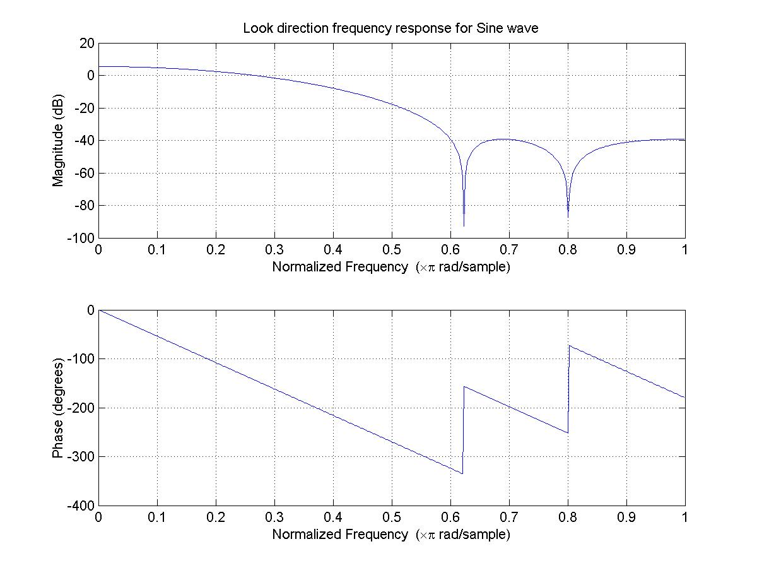
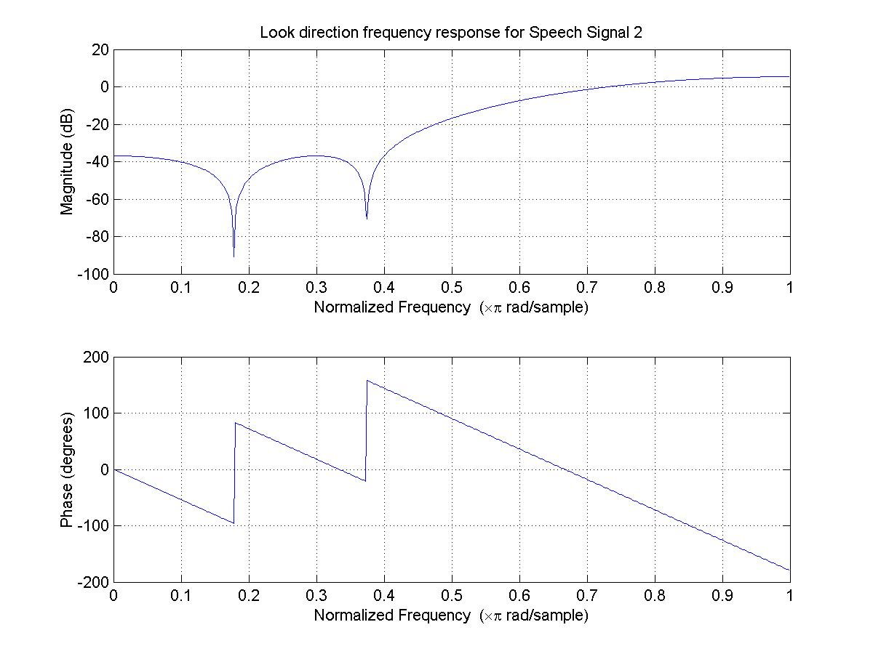
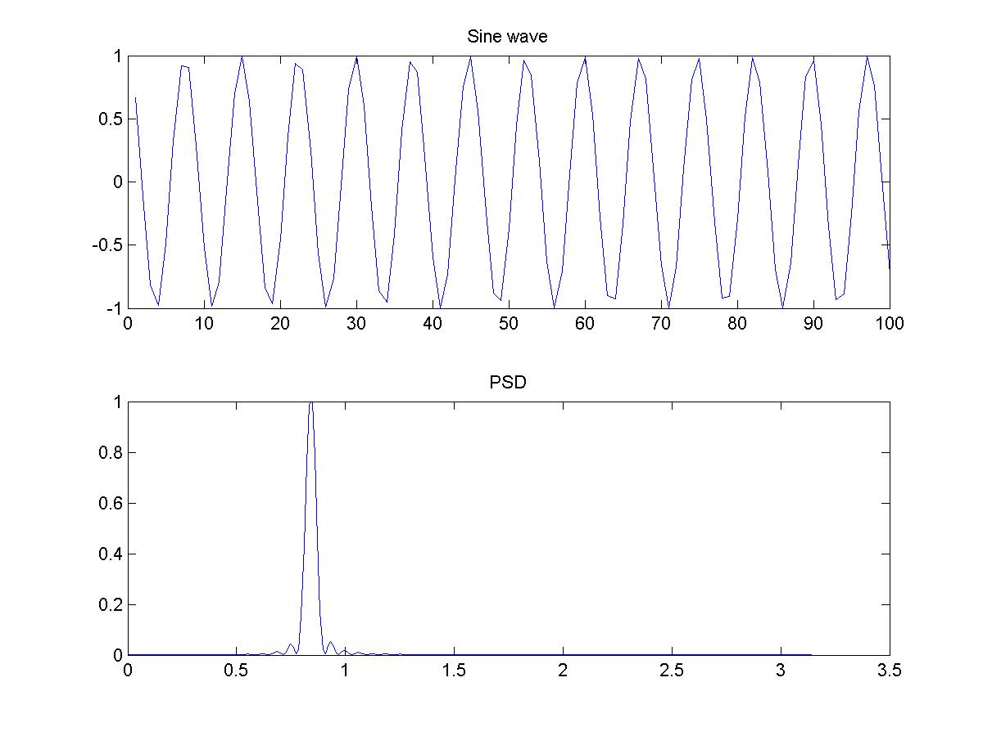
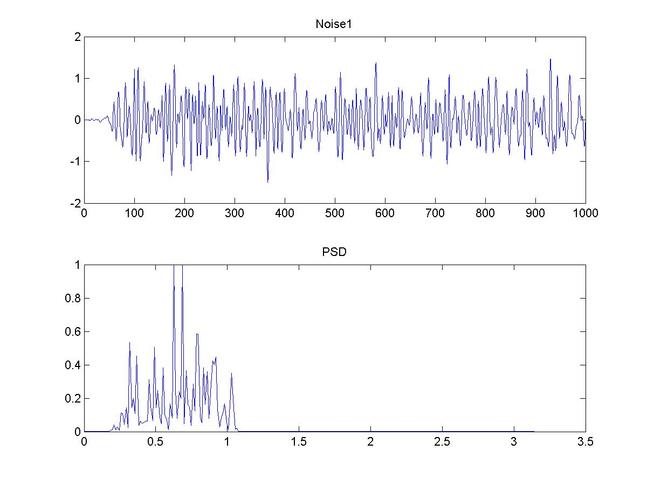
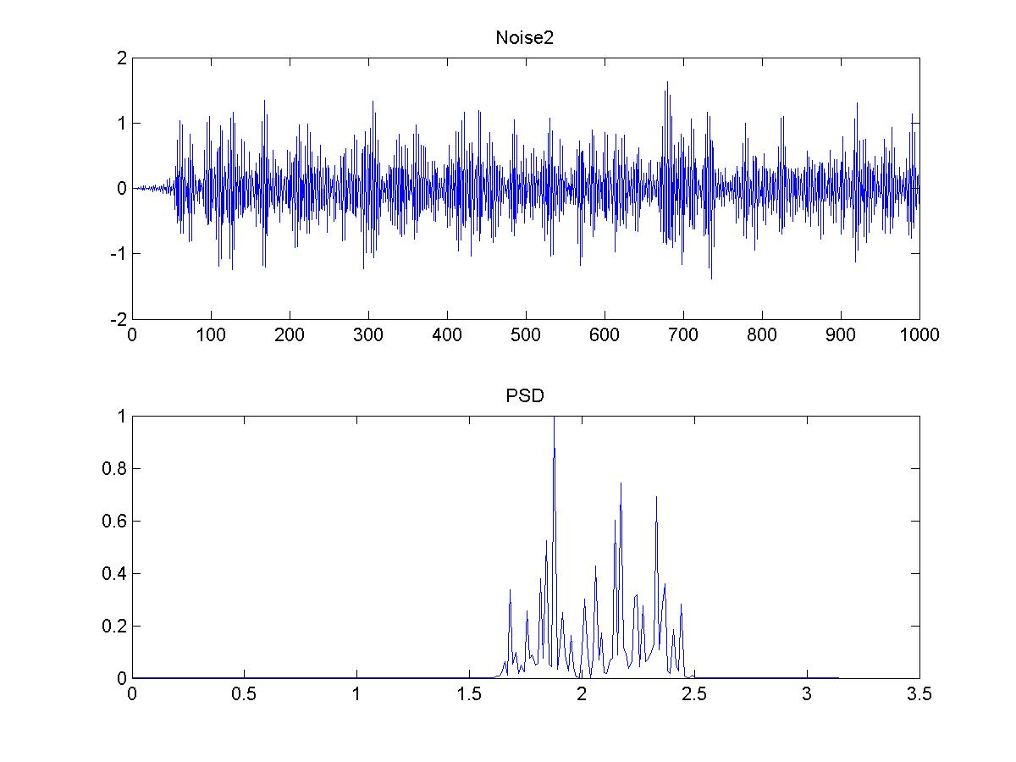
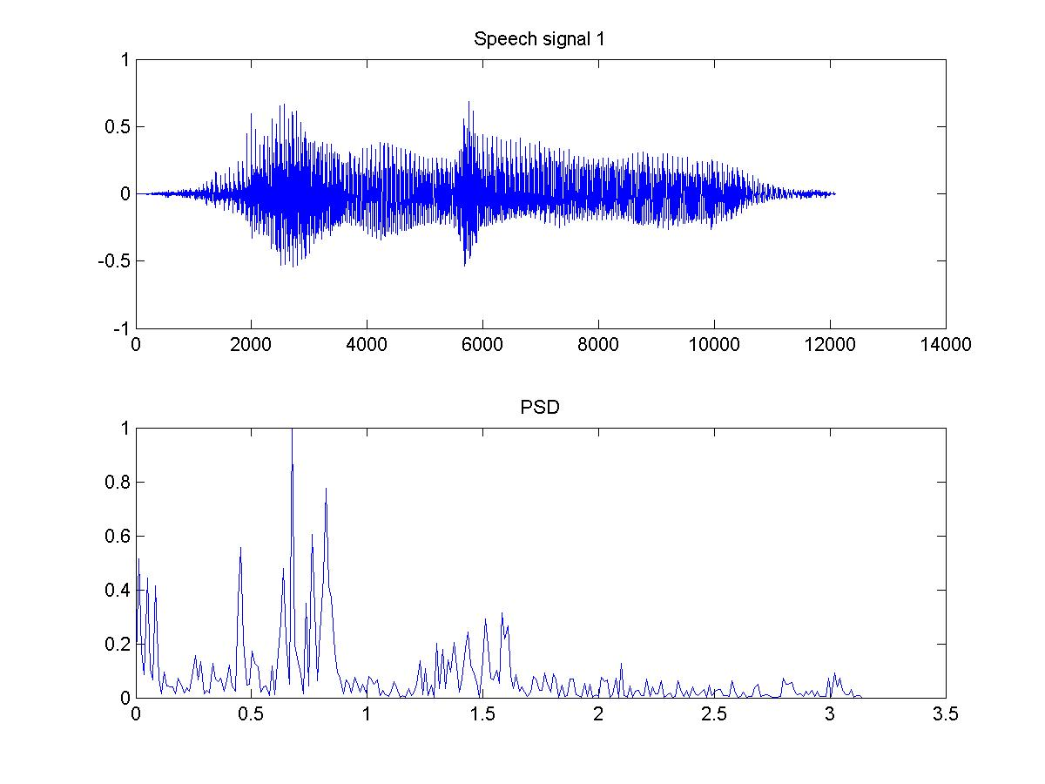
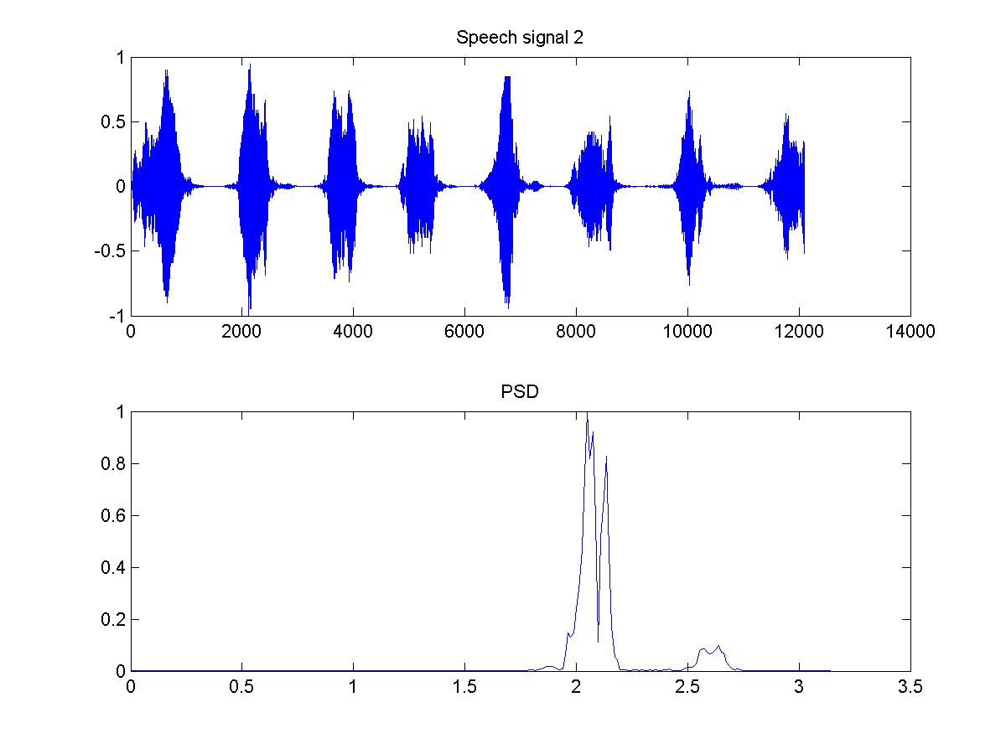
Chapter 7
Simulation RESULTS

The following table tabulates the SNR values for all the simulations carried out. The SNR was measured in the following way. First only the signal was passed through the beamformer and the signal power was calculated. Then only the noise and interfering signals were passed through the beamformer and the noise power was calculated. This operation is justified because of the linearity of the beamformer. Note that since the look direction frequency response is known the output of even the single microphone and sum and delay beamformer was filtered. The plots on the preceding pages show the output of these simulations.
Sim | Single Microphone  SNR (dB) | Delay and sum beamformer  SNR(dB) | Frost Beamformer  SNR(dB)
1 | -08.77 | 01.97 | 04.26
2 | -18.60 | -06.04 | 01.23
3 | -17.98 | -05.11 | 00.04
4 | -08.77 | 01.87 | 05.34
5 | -18.60 | -06.02 | 02.34
6 | -17.98 | -05.40 | 00.02
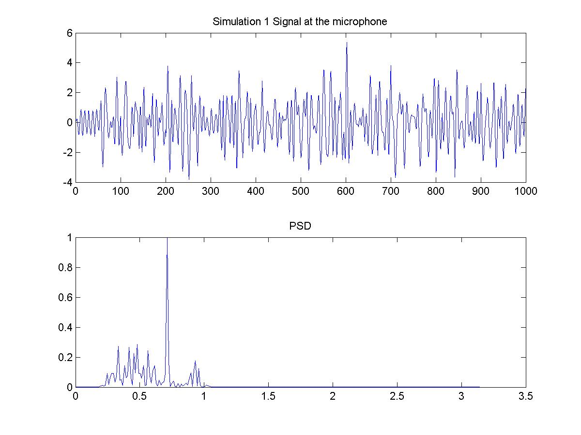
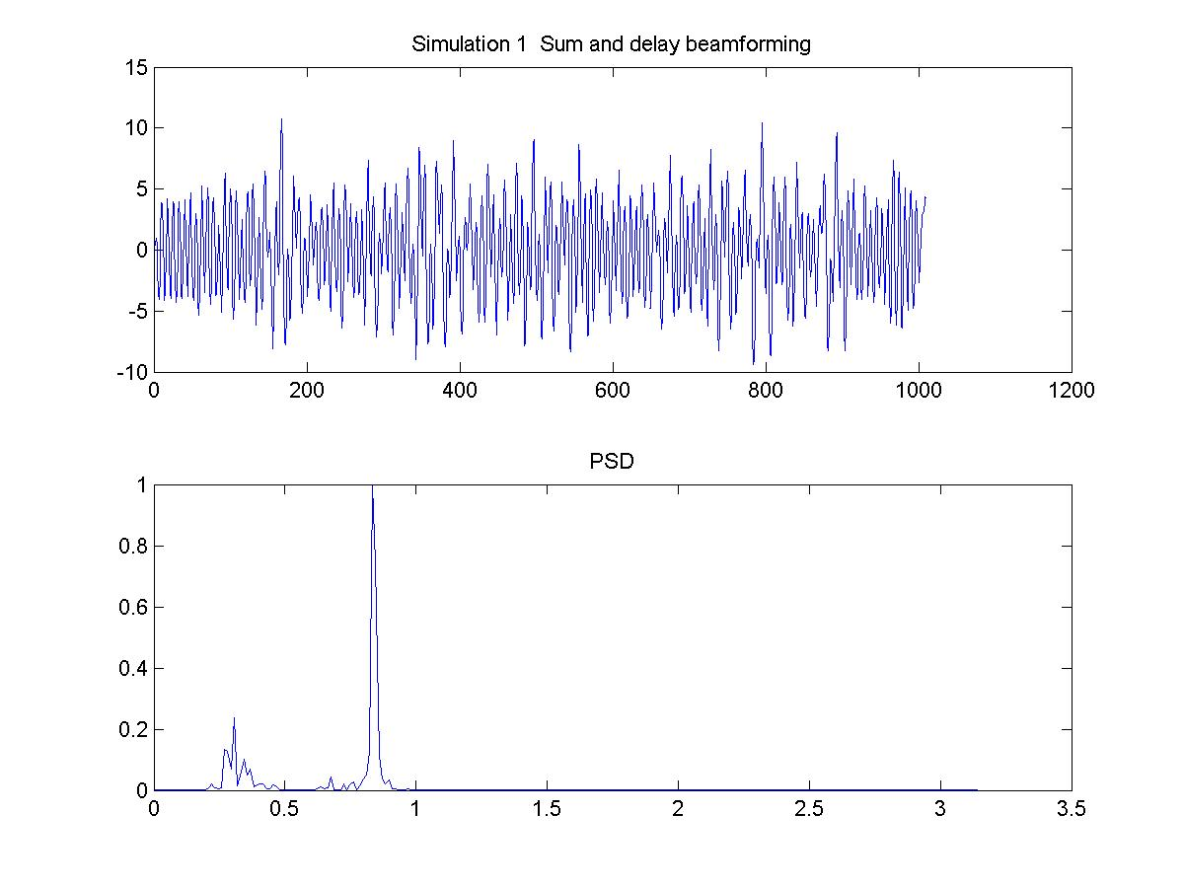
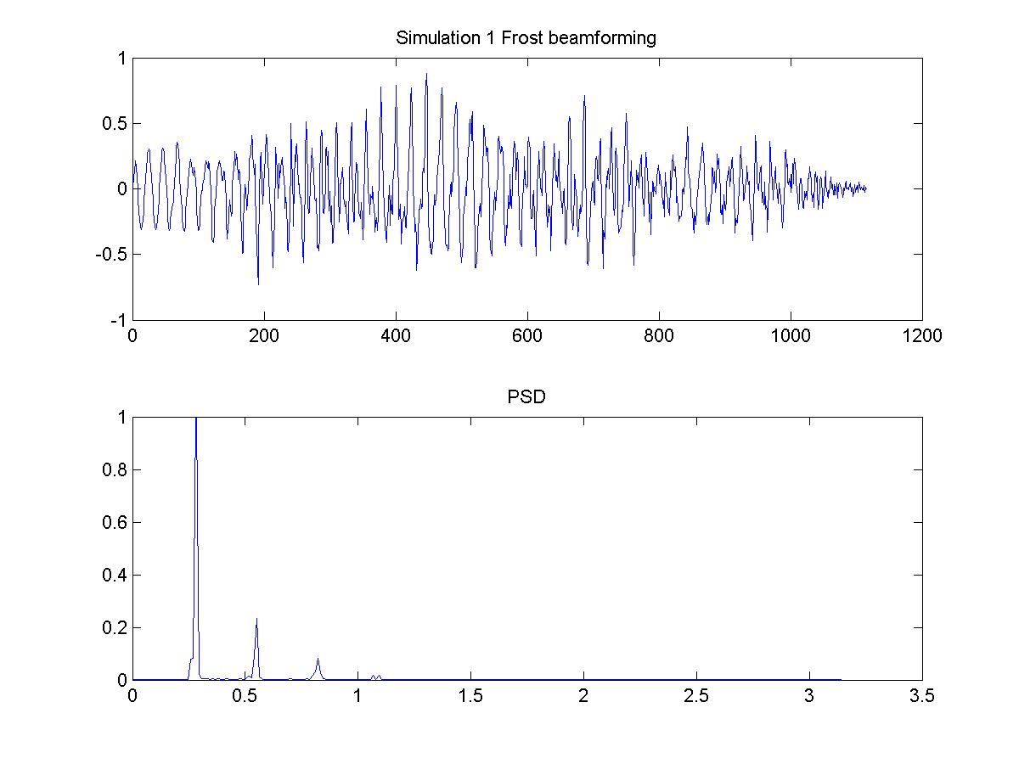

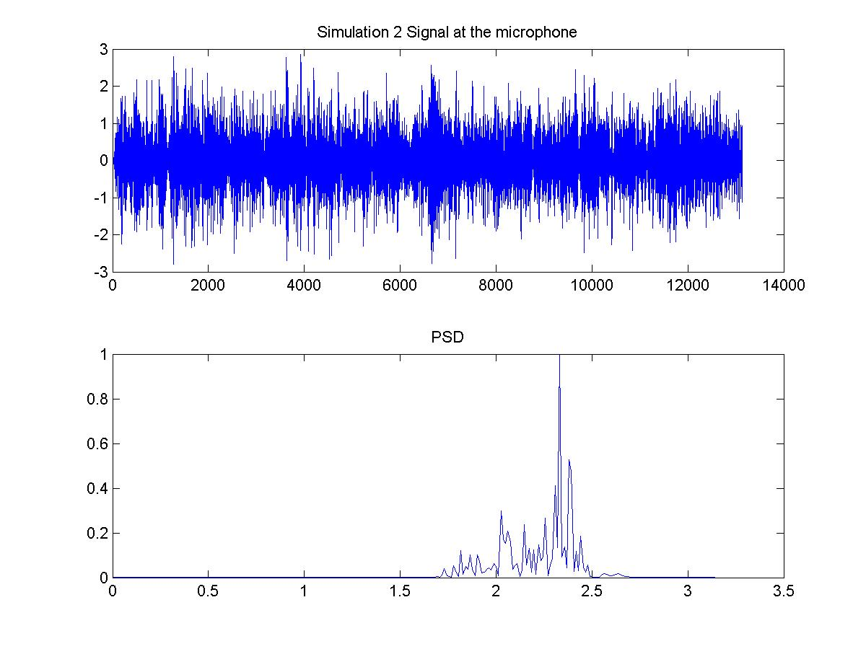
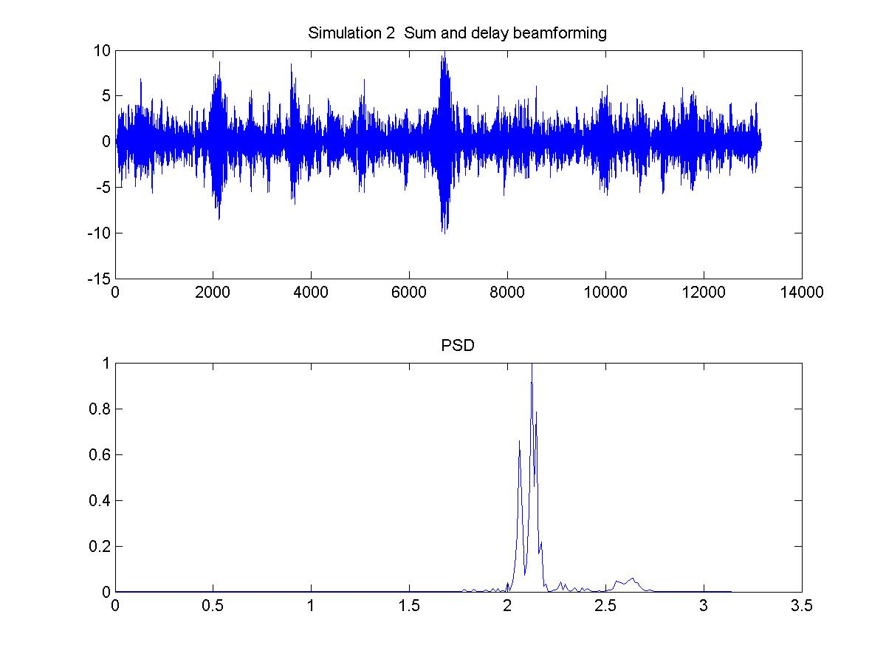

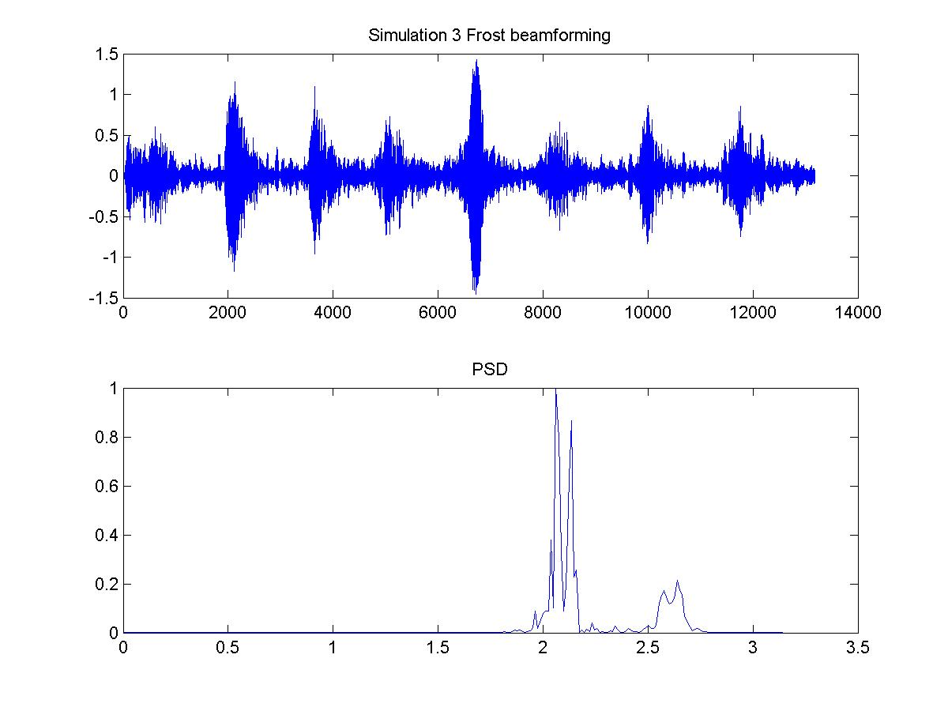

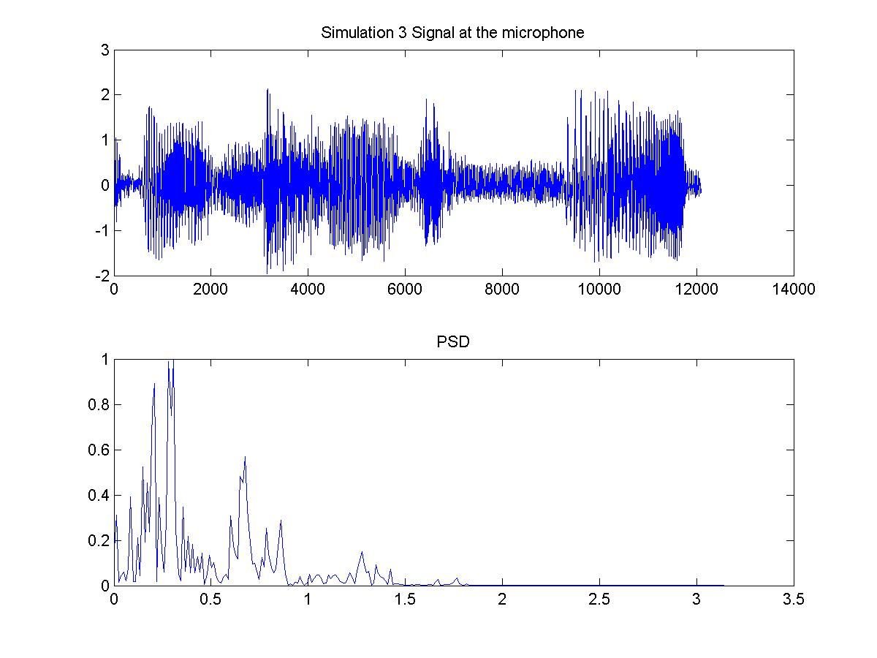
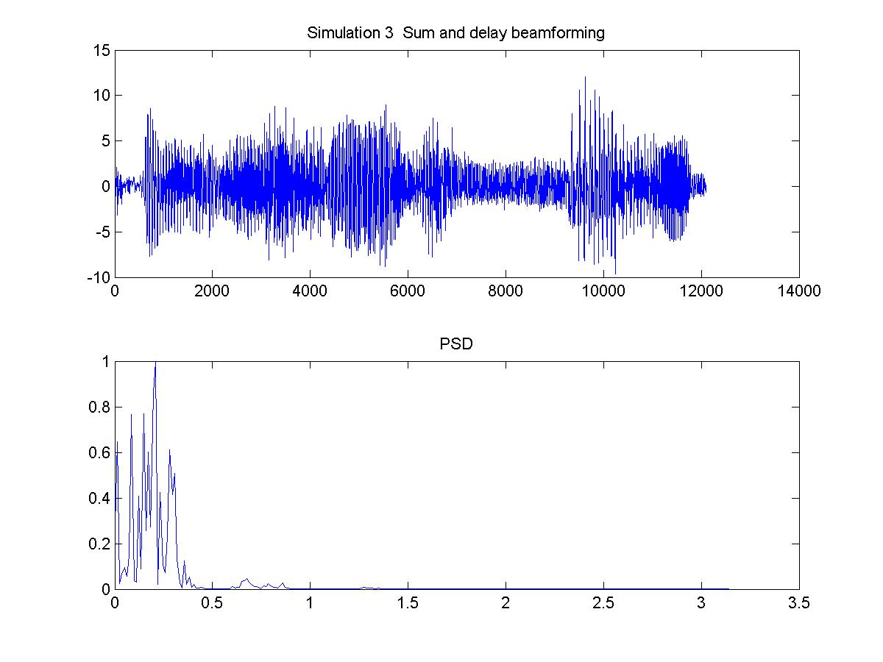

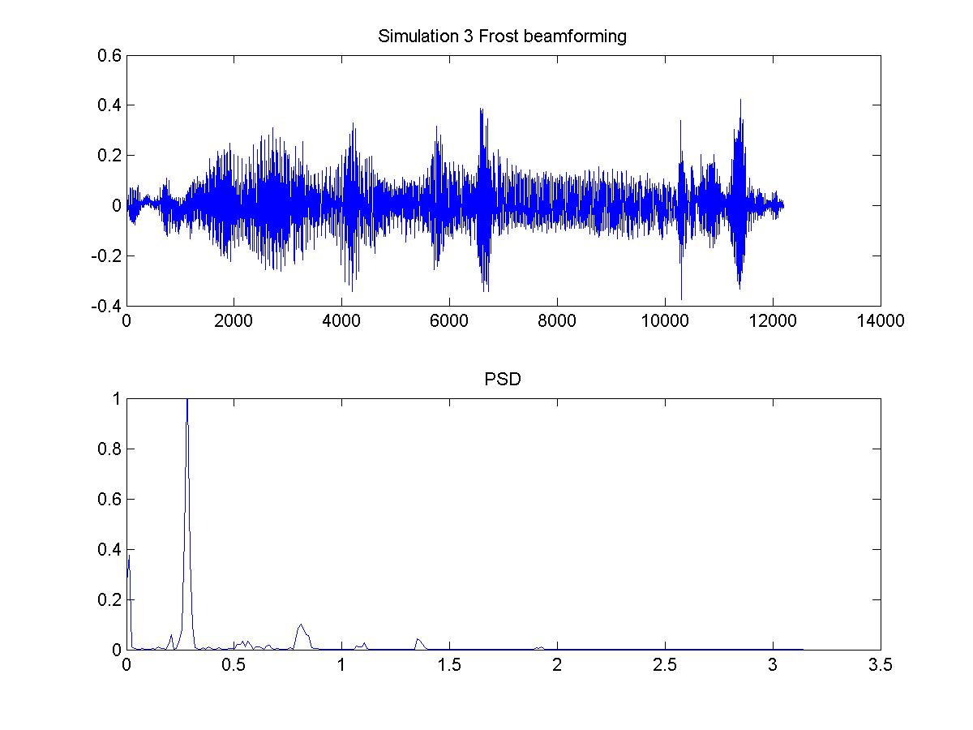

Chapter 8
CONCLUSION
The simulation results obtained indicate that beamforming increases the SNR of the output signal. It can be observed that the improvement is more in case of the Frost beamformer than the simple Delay and sum beamformer.
 | Delay and sum beamforming  (Improvement in dB) | Frost Beamformer  (Improvement in dB)
Simulation 1 | 06.80 | 13.03
Simulation 2 | 12.56 | 19.83
Simulation 3 | 12.87 | 18.02
Simulation 4 | 06.90 | 14.11
Simulation 5 | 12.58 | 20.94
Simulation 6 | 12.58 | 18.00

The MATLAB simulation for Frost beamformer takes a lot of time. Initially I started to implement the beamformer in real-time using the POWERDAQ board and 7 microphones but due to some problems I had to do it in MATLAB. I hope to continue the real time implementation in winter.
References

1. Barry D. Van Even and Kevin M. Buckley. Beamforming: A versatile approach to spatial filtering. IEEE Acoustics, Speech, and Signal Processing Magazine, pages 4--24, April 1988.

2. O.L. Frost III, An algorithm for linearly constrained adaptive array processing," Proc. IEEE, vol. 60, pp. 926-935, Aug. 1972

